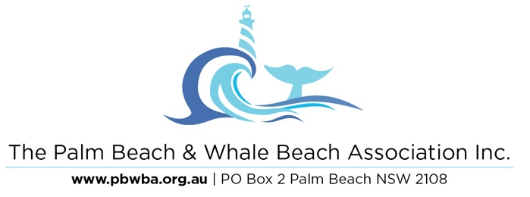
18 March 2020
The Northern Beaches Bike Plan Team
Northern Beaches Council
PO Box 82
MANLY 1655

Northern Beaches Council Bike Plan
The Palm Beach & Whale Beach Association Inc represents the residents and businesses of a particularly beautiful part of the Northern Beaches LGA. The topography of the area is challenging, with narrow winding and often steep roads, most without footpaths. The principal access road is Barrenjoey Road, which is a two-lane road, without footpaths between Careel Bay Road and Nabilla Road. The main secondary road, Whale Beach Road, has some short stretches of footpath but much of its length has no footpaths – the roadway is so narrow that there are few stretches where cars travelling in opposite directions can pass – for much of its length, one driver will have to give way. There is parallel resident parking on most of our roads.
For the entirety of our area, the whole of the road corridor is too narrow for the inclusion of any cycleway at all, without the removal of resident parking and the acquisition of land from private owners on one or both sides. Given the presence of parallel parking on most of our roads and the need for a “door zone” in accordance with AusRoad Guidelines, there is simply no possibility of including cycleways, on even one side of these roads.
The nature of our topography means that most residents and visitors need to rely on cars, as public transport is limited and cycling is not practicable. The result is that bicycles and cars will have to share the roadways and the forbearance between them normally exhibited should be encouraged. Prioritisation of bikes over cars is not practicable.
Our residents are resolutely opposed to shared footpaths, as they are dangerous to pedestrians, particularly older pedestrians. The Council has already agreed that the coastal pathway through Palm Beach and Whale Beach will not have shared pathways because of its variable width and narrow stretches. Our topography means that there are no “run-off” areas to allow avoidance as there is, for example, in Winnererremy Park, Mona Vale.
We have noted the comment in the Bike Plan that “Palm Beach is a popular destination for road cyclists” and the inclusion of a road cycling loop covering Barrenjoey Road, Beach Road, Ocean Road, Florida Road and Whale Beach Road. Given the nature of these roadways, as outlined above, we believe this is unwise. In particular, on the stretch of Whale Beach Road between Norma Road and Surf Road, a downhill section, road cyclists already ride at speeds which are dangerous to themselves, pedestrians and cars. It would improve safety on this loop if the speed were limited to 40 km/h from either Barrenjoey Road at Careel Bay or Iluka Road South, Palm Beach back to the junction of Whale Beach Road and Barrenjoey Road.
In our view, the absolute priority in our area is the construction of a pathway from Careel Bay Road, North Avalon to Nabilla Road, Palm Beach. There is a need for pedestrians to be able to walk from Avalon to Palm Beach, something that is impossible in the current state of Barrenjoey Road. This would be in accordance with the Council’s Connectivity Plan and its desire to encourage walking.
In relation to facilities for cyclists, there is a need for a number of bike lockers in Pittwater Park North for cyclists who use the ferry from Ettalong to reach the Northern Beaches and then cycle to work. There is a need for some bicycle hoops in Pittwater Park South, on Ocean Road and at the beach at Whale Beach.
We appreciate the opportunity to put forward our views on the Bike Plan.

A/Prof Richard West AM
President
Palm Beach & Whale Beach Association, Inc.

